Name: Ulysses Burden III
Assignment: 3.2 Project Design Week3
Abstraction, Constructors, Access Specifiers
Date: November 30, 2025
Github Link: Release Phase#3 · UBSDFS/Contact_Management_App_Java

Rolodex Application – Class & OOP Design Summary
Project: OOP, Inheritance, Interface, Polymorphism & Composition
Overview of the Application
This application is a console-based Rolodex system that allows the user to store and manage different types of contacts. It demonstrates object-oriented programming concepts including inheritance, interfaces, polymorphism, and composition. The program also uses an ArrayList to store multiple contact objects.
The user interacts with the system through a menu that performs basic operations such as adding contacts, searching for a contact, and displaying all contacts or contacts by type.
Class Breakdown

Contact (Abstract Superclass)
Represents the structure for all contact types (Family,Friend,Business). Contains common fields like firstName, lastName, email, phoneNumber, and address (composition). Implements the ContactType interface. Provides shared behaviors like getters, printSummary(), and toString(). Demonstrates inheritance, interface implementation, composition, and encapsulation.

Friend (Subclass of Contact)
Adds a nickname field specific to friends. Overrides getContactType() and extends the base toString() output. Demonstrates inheritance, polymorphism, and overriding.
Family (Subclass of Contact)
Adds a relationship field (e.g., 'Brother', 'Cousin'). Overrides getContactType(). Demonstrates inheritance, polymorphism, and overriding.
BusinessContact (Subclass of Contact)
Adds companyName and jobTitle fields. Overrides getContactType(). Demonstrates inheritance, polymorphism, and overriding.
Address (Composition Class)
Contains street, city, state, and zipcode. Used inside Contact to represent addresses. Demonstrates composition and encapsulation.
ContactType (Interface)
Declares getContactType(). Enforced by Contact and implemented by all subclasses. Supports filtering and polymorphic behavior.
ContactManager (Controller Class)
Controls the entire application: stores contacts, handles user input, and executes menu operations. Uses an ArrayList to store contacts and supports adding, searching, and displaying contacts. Demonstrates polymorphism and control flow logic.
OOP Concept Summary
Inheritance: subclasses extend Contact.
Interface: ContactType implemented by Contact and overridden by subclasses.
Polymorphism: List<Contact> holds different contact types.
Composition: Contact contains an Address.
ArrayList: Used for dynamic storage and iteration.
Menu + CRUD: Add, find, and display operations implemented.

Methods:
readString(String prompt) - Reads input from user.Used to collect names, emails, phone,ect.
readInt(String prompt) - Reads integer input for menu selections.
findContactByName()- Searches the ArrayList<Contact> by name and returns matching object from Contact.
addContact()-Collects user input to create the contact with the appropriate attributes and assign a contact type

Screen Captures of program running.
Application Startup and Menu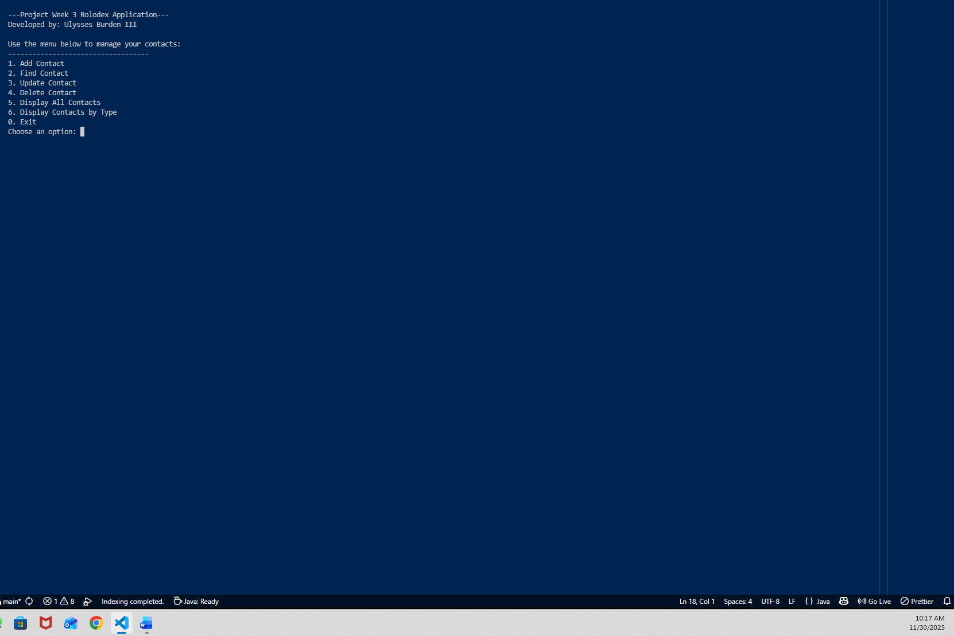

Adding Friend Contact
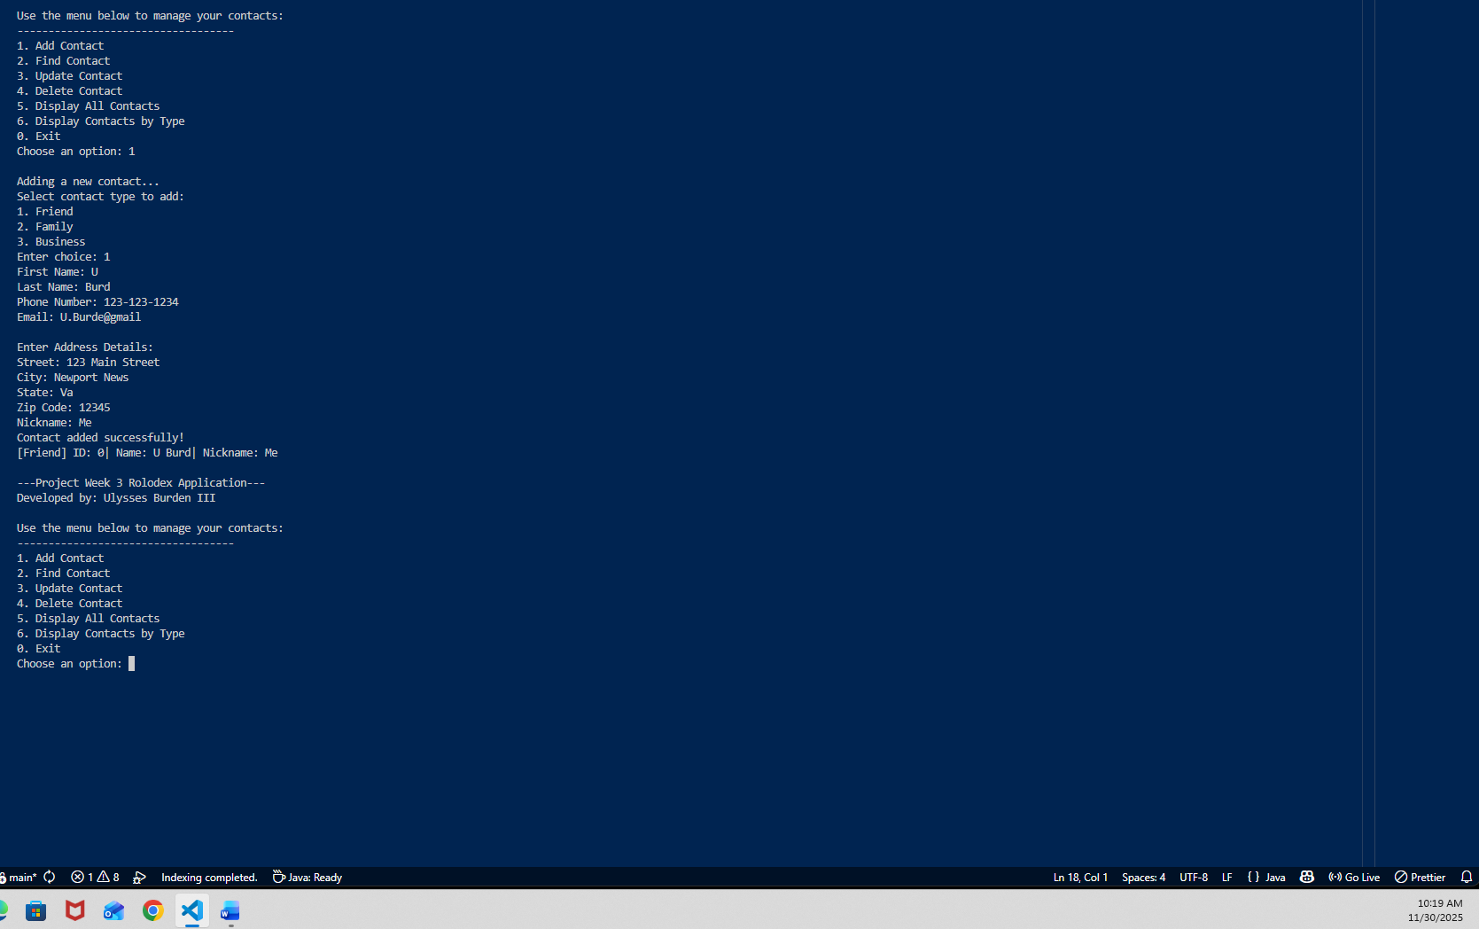

Displaying All Contacts:
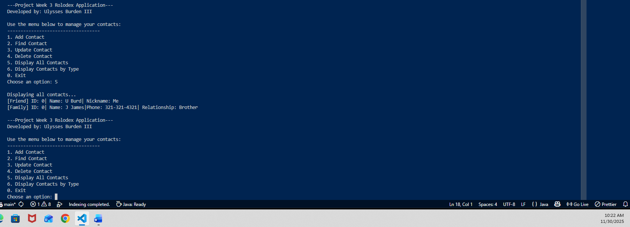

Display Contact by Type:
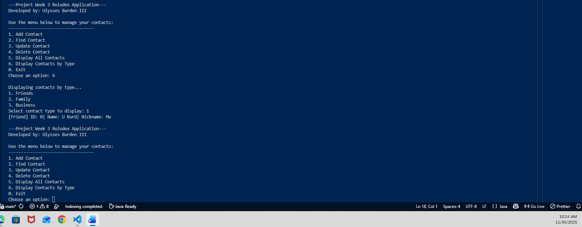
Deleting Contact:
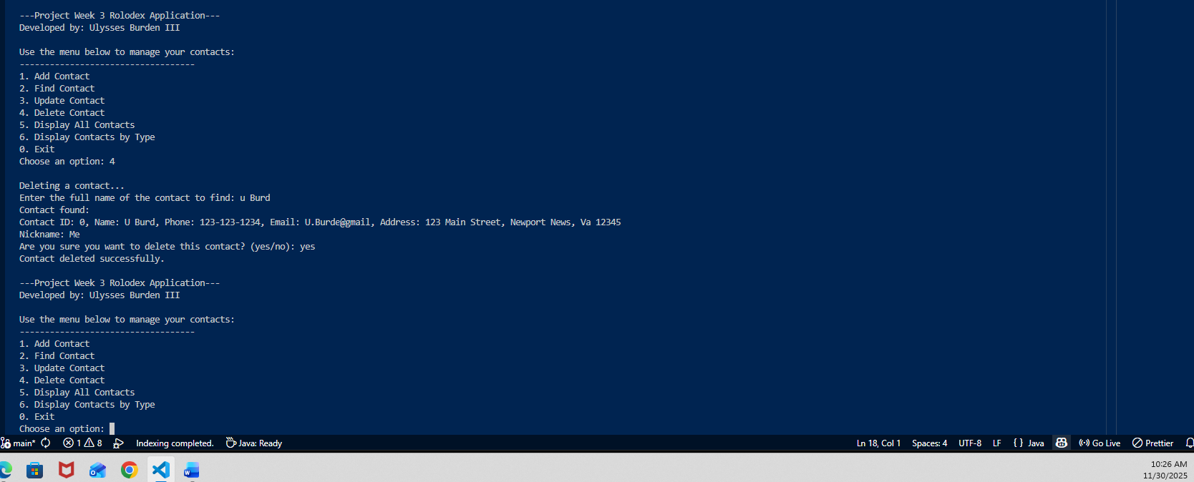
Find Contact: 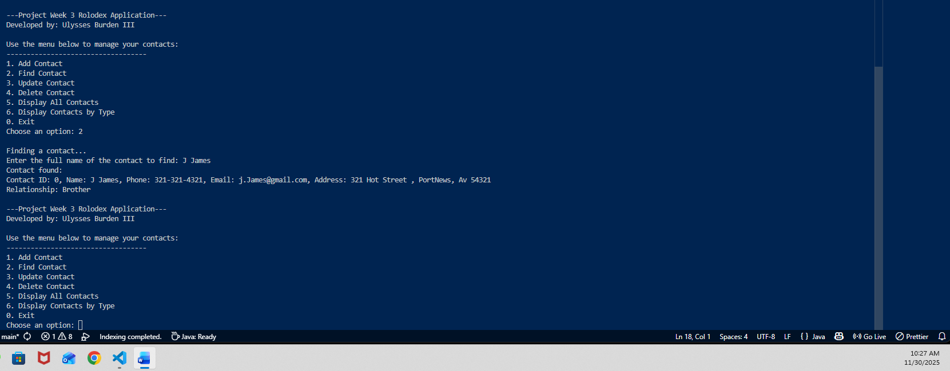
Exit Program:
